Software Requirements Specification Template

SMART INVENTORY – IOS

Software Requirements Specification

Version - 1.0
September 09,2018

Team Members
Bharadwaj Dasari
Vamshi Raj Jennaikode
Midhun Kumar Kurapati
Shruthi Patlolla
Manogna Sivangula
Naga Ravi Teja Sai Mohan Vummidi

Submitted in partial fulfilment
Of the requirements of
CSIS 44-691 Graduate Directed Project 1

Revision History

Date | Description | Author | Comments
09/27/2018 | Version 1.1 | Manogna S | First Revision

Document Approval

The following Software Requirements Specification has been accepted and approved by the following:
Signature | Printed Name | Title | Date
Zhengrui Qin | Dr. Zhengrui Qin | Client | 09/29/2018
Vamshi Raj | VamshiRaj Jennaikode | Lead Developer | 09.30/2018

Table of Contents

Table of Contents Page Number

- Introduction
  - Purpose
  - Scope
  - Definitions, Acronyms, and Abbreviations
  - References
  - Overview
- General Description
  - Product Perspective
  - Product Functions
  - User Characteristics
  - General Constraints
  - Assumptions and Dependencies
- Specific Requirements
  - External Interface Requirements
    - User Interfaces
    - Hardware Interfaces
    - Software Interfaces
    - Communications Interface
  - Functional Requirements
  - Use Cases
  - Class/Objects
  - Non-Functional Requirements
3.5.1. Performance
3.5.2. Reliability
    - Availability
    - Security
    - Portability
  - Inverse Requirements
  - Design Constraints
  - Logical Database Requirements
  - Other Requirements
  - Prototypes (for complete project)
  - Use Case Diagrams
- Design
4.1. ER diagram
4.2. GUI
- Analysis Models
4.1. Data Flow Diagram
4.2. Sequence Diagram

Unit 3. SPECIFIC REQUIREMENTS
  - External Interface Requirements
    - User Interfaces
User interfaces used in this project are mentioned below, welcome screen, sign-up screen, sign-in screen of user, sign-in screen of admin.
1.Welcome screen 2. Admin login screen
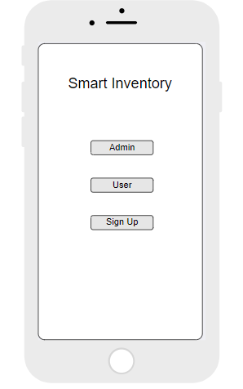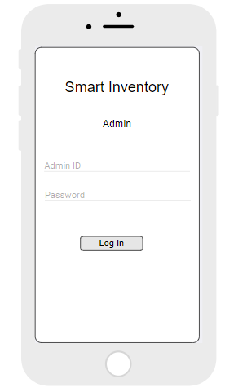
3.User login screen 4. Sign-up screen
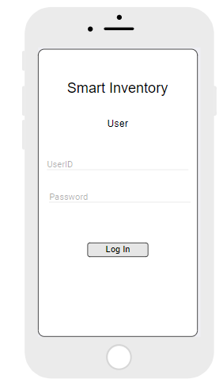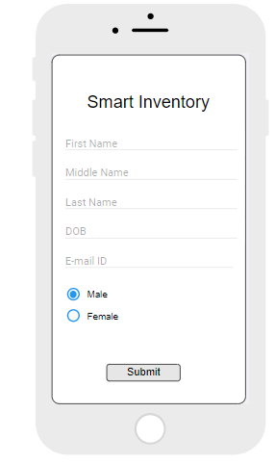

    - Hardware Interfaces
Our hardware interfaces are iPhone, iPad, MacBook, Mac Pro. Memory should be 64 GB. Operating system using is MAC. Processor is 2.3GHz dual-core Intel Core i5.
    - Software Interfaces
As for the programming environment, OS X is a UNIX system and as such it comes with most of the tools you need to develop. The IDE must be downloaded separately from Apple, it’s called "XCode". The current version of the IDE is 4.x but version 5.x will be released once Mavericks is out.
XCode comes with an iOS emulator, so you do not need to have an actual iPhone during development, it is however recommenced since working in a virtual environment is never the same as working on the actual hardware (Host-Target Development Model). In case you choose to use the iOS emulator, more RAM and possibly an SSD disk will speed things up.
XCode also comes with a dynamic tracing tool called Instruments. Instruments is based on the DTrace tracing framework which was originally developed by Sun Microsystems on the Solaris platform.
You need an iOS Developers account from apple, you can get one at developer.apple.com for about 100$.
3.1.4Communications Interface
Google Docs, sheets and slides:
Google Docs, sheets and slides lends itself to collaborative projects in which multiple authors work together in real time from geographically diverse locations. All participants can see who made specific document changes and when those alterations were done. Because documents are stored online and can also be stored on users' computers, there is no risk of total data loss as a result of a localized catastrophe. However, the Internet-based nature of Google Docs, sheets and slides has given rise to concerns among some authors that their work may not be private or secure.
We use this for creating project documents, sheets and slides for presentation. It is reliable for team-work.
Share Point:
SharePoint is a web-based collaborative platform that integrates with Microsoft Office. Launched in 2001, SharePoint is primarily sold as a document management and storage system, but the product is highly configurable, and usage varies substantially between organizations.
We use share point to work with team on same platform as Microsoft word.
Slack:
Slack is a cloud-based set of proprietary team collaboration tools and services, founded by Stewart Butterfield. Slack began as an internal tool used by his company, Tiny Speck, in the development of Glitch, a now defunct online game. The name is an acronym for "Searchable Log of All Conversation and Knowledge".
We used to share or receive any type size of files in slack.
Outlook:
It is Microsoft e-mail service. We use outlook to send and receive mails. Used to contact team members.
3.2 Functional Requirements
3.2.1 Admin Modules

- Login
Admin can login into the system with some specific privileges using his credentials.
Password should be at least 8 characters, it should be a combination of letters and numbers and should contain at least on special character.
- Add or Remove Users:
Admin can add or remove the users from system.
- Add or Delete Items
Admin should have an option to add or delete items in the inventory.
- Post updates on the dashboard
Admin can post the updates on dashboard, so that all the users can view the data.
- One to One communication
Admin can contact the user on personal chat.
- Send Shipping labels to user
Admin should be able to send the hipping labels to the users to send the products.
- Confirmation up on receiving the product
Admin should send a confirmation note to user up on receiving the item.
- Send amount to user.
Admin can able to send the money to the user through PayPal.
- View transaction history
Can view the transaction history.

    - User Modules

- Sign up
New user should be able to sign up for inventory system.
- Login
Users can able to login to the system with their credentials.
Username should be unique.
Password should be at least 8 characters, it should be a combination of letters and numbers and should contain at least on special character.
- View Admin posts
User can view the admin posts on the dashboard.
- Contact Admin
User can contact admin about the items he has requested and details.
- Send request for selling items
User can send a request to admin about the availability of items.
- Send request for shipping labels
User can request for shipping labels.
- Send an invoice for payments
User should be able to send invoice about the products they have shipped.
- View Transaction records
User should be able to check the transaction history.
- Vendor rating
User can provide rating to vendor about the process.

3.3 Use Cases
A use case is a methodology used in system analysis to identify, clarify, and organize system requirements. The use case is made up of a set of possible sequences of interactions between systems and users in a particular environment and related to a particular goal. It consists of a group of elements (for example, classes and interfaces) that can be used together in a way that will have an effect larger than the sum of the separate elements combined. The use case should contain all system activities that have significance to the users. A use case can be thought of as a collection of possible scenarios related to a particular goal, indeed, the use case and goal are sometimes considered to be synonymous.
A use case (or set of use cases) has these characteristics:
- Organizes functional requirements
- Models the goals of system/actor (user) interactions
- Records paths (called scenarios) from trigger events to goals
- Describes one main flow of events (also called a basic course of action), and possibly other ones, called exceptional flows of events (also called alternate courses of action)
- Is multi-level, so that one use case can use the functionality of another one.
In our project, our use cases are products, invoice, transaction, orders etc., You can see all use cases in Use case diagram section (3.11)
3.4Class/Objects
- User:
To store the user details like name, email, password, type of user.
- Product:
To store the product details like product name, number, quantity.
- Order:
To store the orders details like order number, items in the order and quantity and also the shipments number.
- Shipment:
Shipment is used to store shipping details of each order , it includes shipment id, order id, date and address.
- Transaction:
Transaction describes about all the transaction details with the id, amount, sender and receiver.
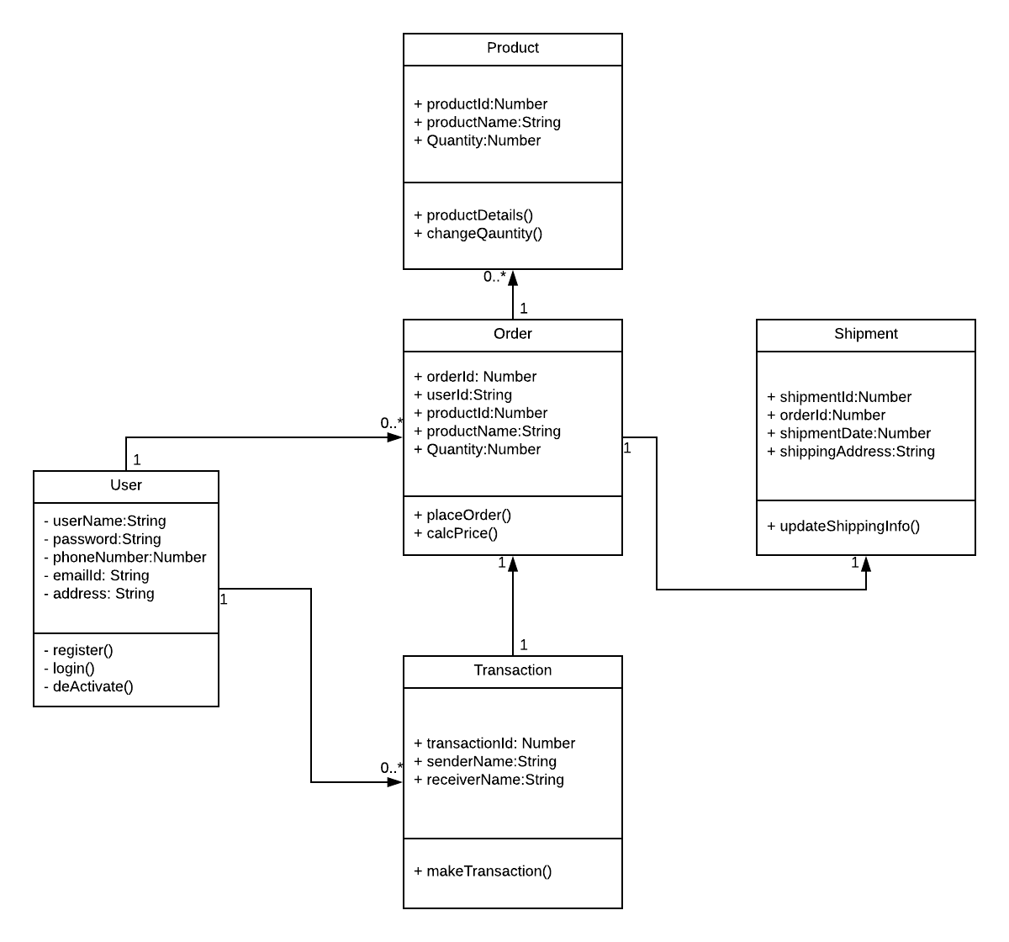
3.5 Non-Functional Requirements
3.5.1. Performance
This is to check the speed of the app that means how fast the app is responding to the actions. Generally, every action should not take more than 20 seconds to respond. In this application it the user should not feel any delay in response when he performed the series of action through the app.
3.5.2. Reliability
Reliability is the percentage of time that the app works correctly without any failures and to deliver the results properly. For our app it is the amount of time the app can run process of selecting products and make transaction of it. It should be 99 percentage in general.
3.5.3. Availability
Availability means the provider systems should meet the agreed availability targets like service downtime and available hours as defined in the operational level agreement. For this app we will specify the downtime periods for month and the services will be not available at that time and rest of the time the services are available.
3.5.4. Security
The provider should resist unauthorized access through the application and should provide access to authorized users only. So, in this app we will authenticate the users based on security mechanisms and provide security for the user’s personal information.
    - Portability
Portability checks for whether the app works for different platforms or different OS environments. As this project is to support only the IOS platform, we will work on to support all the devices which runs on IOS operating system.
  - Inverse Requirements
Inverse requirements state the requirements what the system will not do. It describes the constraints on allowable behavior. In most of the cases, it is easier to state that certain behavior must never occur than to state requirements guaranteeing acceptable behavior in all circumstances. It depends mostly on the client.
  - Design Constraints
Most mobile products are failed because of not limiting the application design. Here are some design constraints that we are planning to use.
1.Client-side storage: From the statistics the average app loses more than 50% of the users within 3 days because of the storage problem that users are facing.
2.Update in the Application: If the update has any problems then there’s a chance of reduction in the users. So, the update must be fully tested and should be bug free.
  - Logical Database Requirements
Specify the logical requirements for any information that is to be placed into a database, like
- Types of information used by various functions
- Frequency of use
- Integrity constraints
- Data entities and their relationships
  - Other Requirements
A Mac Book with minimum requirements like 8 GB RAM and 500 GB hard disk and should be able to run X-Code. An iPhone with minimum model of iPhone 6 is required for testing the application. IOS developer account is required to access more granular control over the operating system entities. A NoSQL database for storing data related to the project.
  - Prototypes (for complete project)
Prototype is an early sample, model, or arrival of an item worked to test an idea or process or to go about as a thing to be repeated or learned from.
Categories of Prototypes:
Proof-of-Principle Prototype serves to verify some key functional aspects of the intended design, but usually does not have all the functionality of the final product.
A Working Prototype represents all or nearly all of the functionality of the final product.
A Visual Prototype represents the size and appearance, but not the functionality, of the intended design. A Form Study Prototype is a preliminary type of visual prototype in which the geometric features of a design are emphasized, with less concern for color, texture, or other aspects of the final appearance.
A User Experience Prototype represents enough of the appearance and function of the product that it can be used for user research.
A Functional Prototype captures both function and appearance of the intended design, though it may be created with different techniques and even different scale from final design.
A Paper Prototype is a printed or hand-drawn representation of the user interface of a software product. Such prototypes are commonly used for early testing of a software design, and can be part of a software walkthrough to confirm design decisions before more costly levels of design effort are expended
3.11. Use Case Diagrams
A UML use case diagram is the primary form of system/software requirements for a new software program under developed. Use cases specify the expected behavior(what), and not the exact method of making it happen (how). Use cases once specified can be denoted both textual and visual representation (such as UML). A key concept of use case modeling is that it helps us design a system from end user's perspective. It is an effective technique for communicating system behavior in the user's terms by specifying all externally visible system behavior.

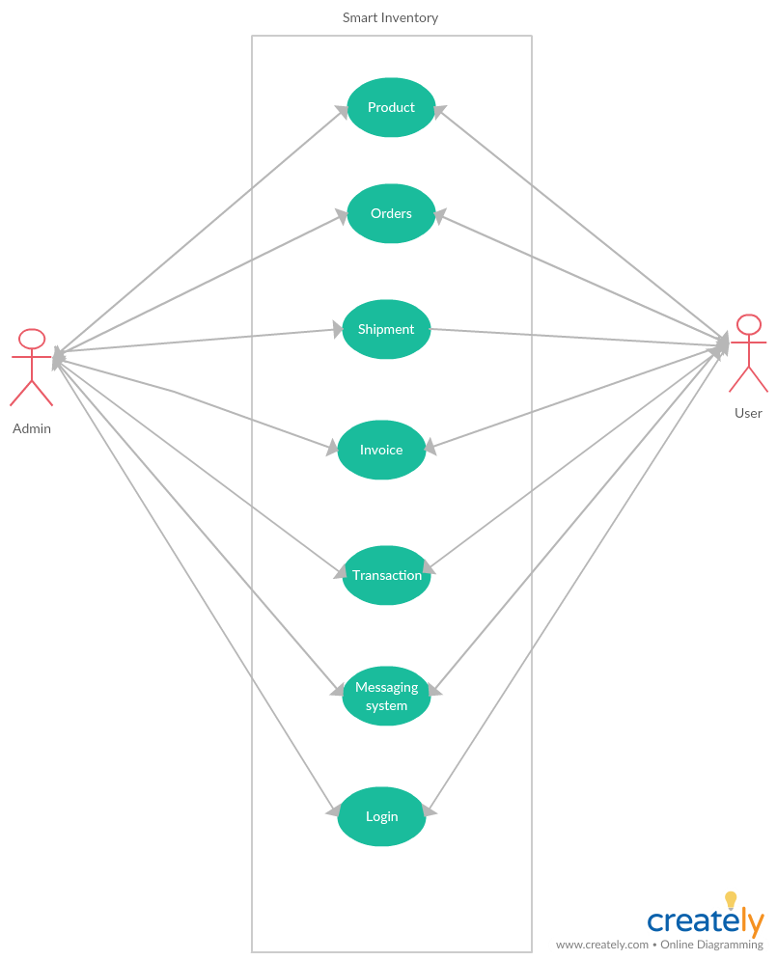
Fig 2. Use-Case Diagram

UNIT 4. DESIGN
4.1. ER diagram:
An entity-relationship model (ERM) is a theoretical and conceptual way of showing data relationships in software development. ERM is a database modeling technique that generates an abstract diagram or visual representation of a system’s data that can be helpful in designing a relational database. These diagrams are known as entity-relationship diagrams, ER diagrams or ERDs.

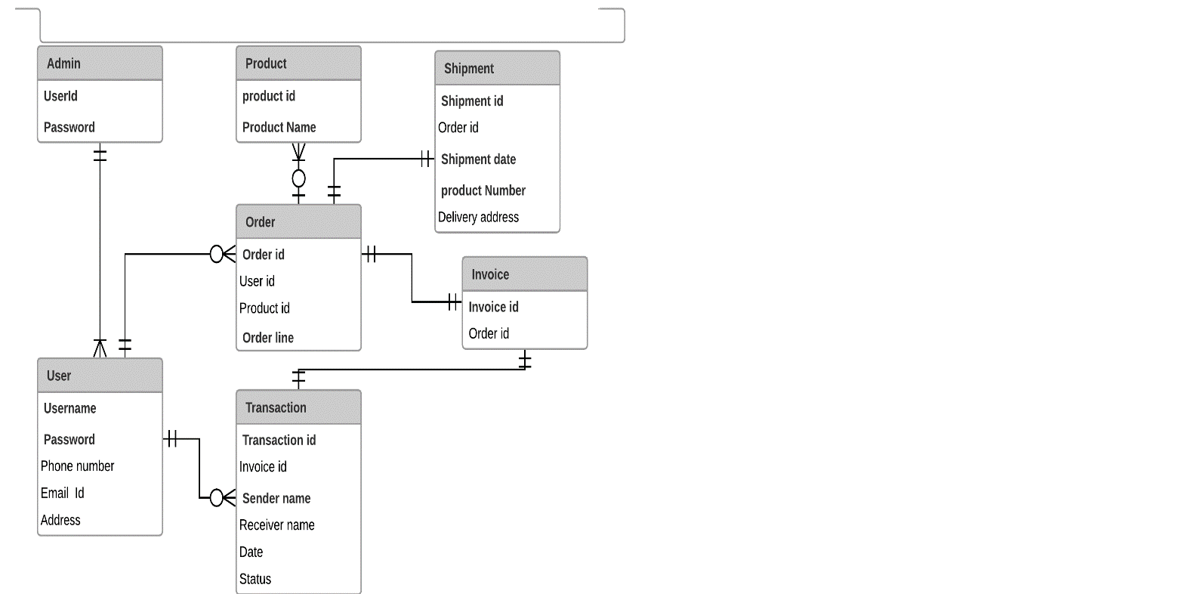

Fig 1. ER Diagrams

4.2. GUI:
Mockups reflect the design choices for color schemes, layouts, typography, iconography, the visuals of navigation, and the overall atmosphere of the product.

1.Welcome screen 2. Admin login screen
Fig 3. Welcome Screen Fig 4. Admin login screen

3.User login screen 4. Sign-up screen
Fig 5. User Login Fig 6. Signup screen

